[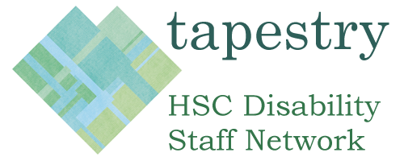](http://wplive1.hscni.net/tapestry/)

**2019 -20 Action Plan**

**Theme One: Promoting the Staff Network**

|  |  |  |
| --- | --- | --- |
|  | **Action** | **Owner / Update** |
| 1 | Promote Tapestry through a range of activities:   * Coffee mornings * Representation at staff health fairs * Information stands * Attend senior team meetings * Remind staff of Chief Executive Statement with quarterly send outs and publish on tapestry website. | Tapestry/BSO Equality Unit |
| 2 | Tapestry website   * Identify new content / review content at each meeting * Track Tapestry website traffic and what staff are using it for * Use website to share agenda and meeting information | Tapestry/BSO Equality Unit |
| 3 | Draft 2x newsletter articles   * 2019/20 meeting dates * Call for staff to become role models/share staff experiences * Carers Leaflet | Tapestry/BSO Equality Unit |

**Theme Two: Raising Awareness of Disability**

|  |  |  |
| --- | --- | --- |
|  | **Action** | **Owner/ update** |
| 4 | Arrange and host one lunch and learn session   * Request Disability Champions to support attendance * Placement Scheme – experience of placement managers, participants and an employment support officers on the scheme | Tapestry/BSO Equality Unit |
| 5 | Focus group for people within our organisations who have disabilities to get together and share their experiences.   * To be shared with managers and staff more widely. | Tapestry/BSO Equality Unit |
| 6 | Hold at least one meeting in a location other than Belfast | Tapestry/BSO Equality Unit |
| 7 | Focus on hidden disabilities   * Staff article | Tapestry/BSO Equality Unit |

**Theme Three: HSC as an employer of choice**

|  |  |  |
| --- | --- | --- |
|  | **Action** | **Owner/ Update** |
| 8 | Short survey distributed to the tapestry mailing list on feedback and suggestions for the network | Tapestry/BSO Equality Unit |
| 9 | Identify and highlight a minimum of two more role models / staff experiences in regional HSC organisations relating to disability, to be published on the Tapestry website | Tapestry/BSO Equality Unit |
| 10 | Create an Easy read version of the BSO complaints process | Tapestry/BSO Equality Unit |
| 11 | Establishment of a Mental Health First Aid team for staff within the regional orgs. | Tapestry with help from BSO HR/Equality Unit |